r

User Research Report and Personas

Project User Research Report | Jasmine Losovsky, Jocelyn Velasquez, Alon Levy, Vincent Tran, Brittney Oeur

INFO 200 Problem Statement | Section AB| TA Amy Oguejiofor

**Table of Contents**

**Problem Brief** **2**

**Existing Solutions** **2**

Existing Solution 1 2

Existing Solution 2 2

Existing Solution 3 3

**Stakeholder Groups** **4**

Stakeholder 1 4

Stakeholder 2 4

Stakeholder 3 4

**User Research** **5**

Surveys 6

Interviews 7

Stakeholder Interview 7

User Interview 1 7

User Interview 2 7

**User Personas** **8**

**Conclusion** **10**

**Bibliography** **10**

**Appendix** **10**

Interview Notes 10

Survey Results 10

# Problem Brief

Just a short brief on your problem space and why you are solving it.

My team aims to tackle the challenge of inadequate and disorganized information regarding the scheduling and locations of various events taking place on the University of Washington campus. By providing a streamlined and accessible system for scheduling and location details of the many different events. We can help enhance students’ experience, foster social connections, and promote educational engagement.

# Existing Solutions

## **Existing Solution 1: Google Events Tool**

* **Overview**
  + The Google Event tool serves as a comprehensive event listing platform, highlighting upcoming and ongoing events within a user’s local area and beyond. Since the service is free, people use this to stay informed about various events and gather pertinent event details.
* **Service Link:**
  + To use this service, users can type into Google search with the query, “UW events”
  + <https://rb.gy/nvbc5> (shortened link)
* **Key Features:**
  + The Google Events tool excels in many key areas:
    - **Event details:** Presents event information, such as time, location, and date
    - **Upcoming Event Highlight:** Users can plan with a display of events spanning from today to the next month
    - **Filtering Option:** Allows the user to filter out the event to in-person or online only
    - **Calendar Integration:** Allows users to save events and paste them onto their Google Calander
    - **Interactive Mapping:** Utilizing Google Maps, enhances user experience by providing a visual representation of event locations
* **Limitations:**
  + The Google Events tool is primarily catered to public events. This means that it may not include information about University of Washington (UW) student-specific events like club meetings, lectures/seminars, or special events such as the Makers Fair, it would not list because they are typically not open to the public. Users seeking information on these types of events would need to explore alternative sources.
* **News Coverage:**
  + As of now, there are no news articles discussing this service.
* **Screenshot of Google Events:**

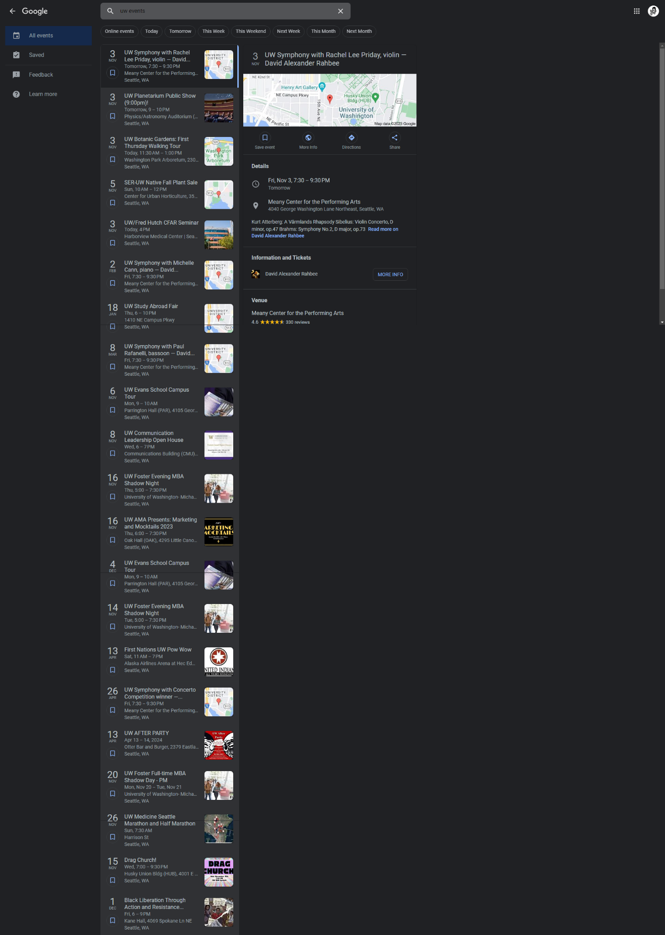

## **Existing Solution 2: Handshake**

* **Overview:**
  + Handshake service is an online job and internship database that serves as a powerful platform for students in their pursuit of job opportunities and career-related events. This service is particularly valuable to students attending one of their partner universities because it will customize job listings and event suggestions based on the user’s school and personal interests, enhancing their career-focused experience.
* **Service Link:**
  + <https://uw.joinhandshake.com/stu/events?collection=ALL&eventFormat=HYBRID&sort=RELEVANCE&date=ALL>
* **Key features:**
  + Handshake excels in many key areas:
    - **Participant Information:** It provides insights into the number of participants attending these events, offering a sense of event popularity.
    - **Event Format:** Users can determine whether events are hosted online or in-person, helping them plan their attendance accordingly.
    - **Event Details:** Presents event information, such as time, location, and date. In addition, it shares what companies will be hosting that event and it states what type of event it is, such as a hiring event, career fair, or a guidance fair.
    - **Job Postings:** In addition to event information, users can explore job postings relevant to their career interests.
* **Limitations:**
  + HandShake is primarily focused on career-related events and job opportunities. It does not encompass non-career-related events such as club meetings, lectures/seminars, or special events catered to a specific university. Therefore, University of Washington (UW) students seeking information about club meetings or non-career events may need to explore alternative sources.
* **News Coverage:**
  + The news article discusses how recruiters on Handshake take a very long time to reach back to their candidates regarding their status. Students have been more successful with LinkedIn and Indeed in their careers.
    - <https://nyunews.com/opinion/2022/09/20/nyu-students-should-abandon-handshake/>
* **Screenshot of Handshake:**
  + **General landing page:**

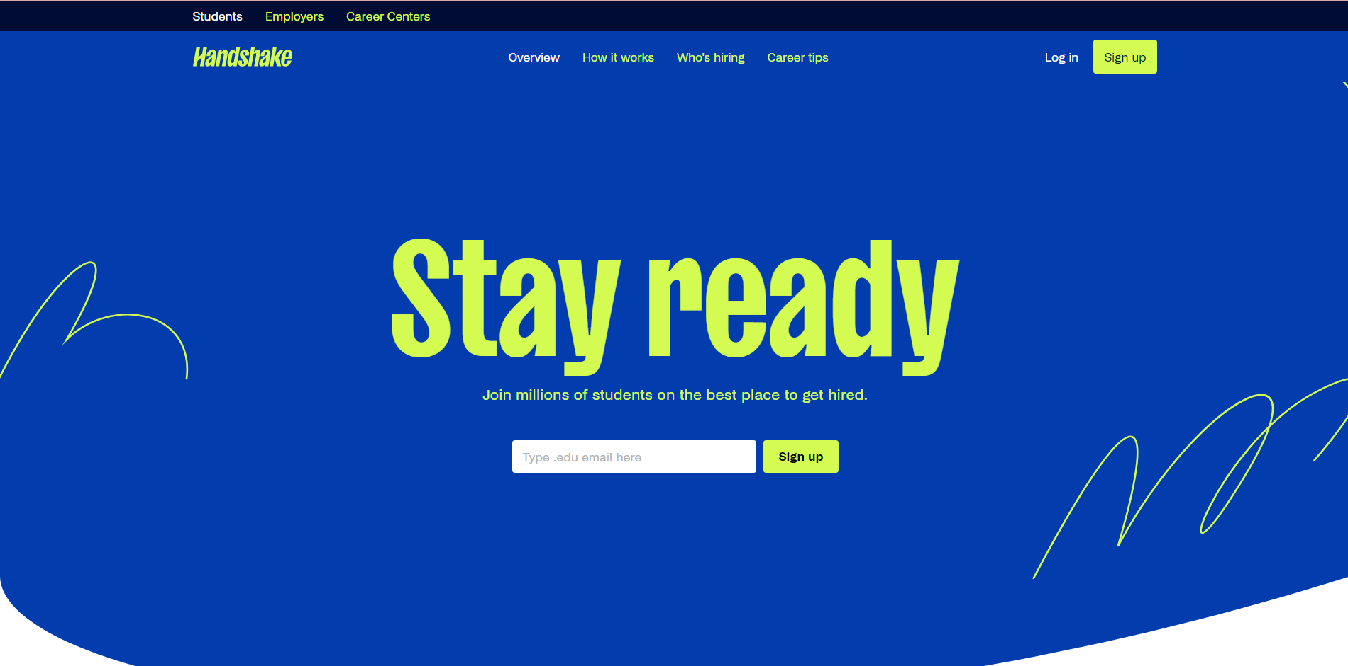

* + **University of Washington (UW) event page:**

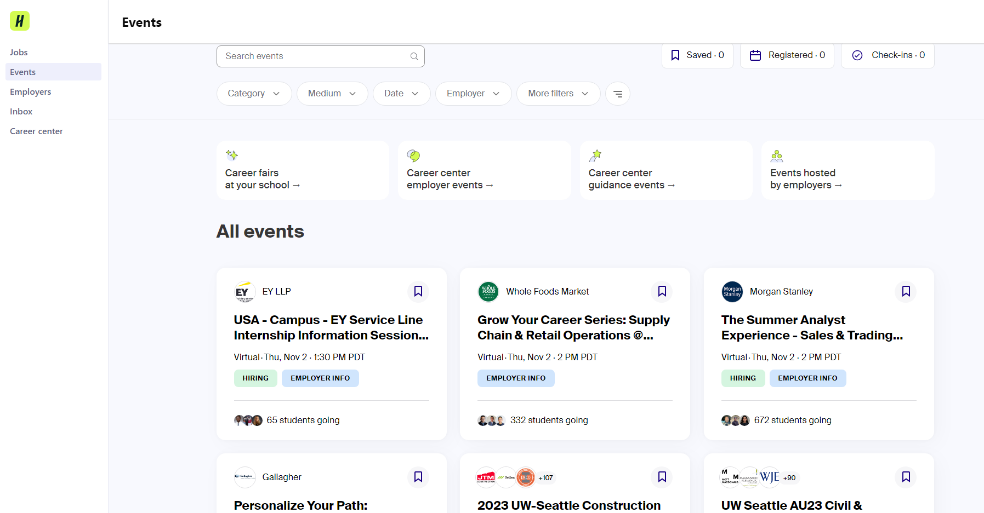

## **Existing Solution 3: HuskyLink (RSOs)**

* **Overview:**
  + HuskyLink, at the University of Washington (UW) Seattle campus, is a platform designed for Registered Student Organizations (RSOs). RSOs are student-led groups and clubs officially recognized by the university. HuskyLink serves as a centralized hub where these student organizations can manage their activities, publicize events and meetings, and engage with fellow students. UW students leverage this service to explore various of campus events and engagement prospects.
* **Service Link:**
  + <https://huskylink.washington.edu/>
* **Key Features:**
  + HuskyLink (RSOs) excels in many key areas:
    - **Campus relevance:** It is designed exclusively for University of Washington (Seattle) students, offering a platform where students from registered organizations can announce their meetings, enabling interested users to participate.
    - **Organization Discovery:** With its simple layout (not cluttered), users can easily find and connect with student organizations they may be interested in, fostering involvement and engagement.
    - **Involvement Tracking:** The service allows students to track and monitor their participation in various campus activities and organizations. Similar to Google Events, it allows students to seamlessly import event details into their Google Calander
    - **Campus Navigation:** Provide links to other campus buildings
    - **Filtering:** Users can categorize events by themes, aligning them with their preferences and interests. Moreover, the service allows for the filtering of events based on additional perks, such as the availability of free food, providing added incentives for participation.
* **Limitations:**
  + HuskyLink lacks an embedded map feature, which is present in Google Events, for visualizing event locations. Furthermore, its focus is primarily on serving students from the Seattle campus of the University of Washington, limiting service to Bothell and Tacoma campuses. Additionally, it does not encompass all ongoing events such as lectures/seminars, special events, exhibits performances, and more at UW (all campuses), which will push users to leave the website to seek out alternative sources for information on those events.
* **News Articles:**
  + As of now, there are no news articles discussing this service.
* **Screenshot of HuskyLink**

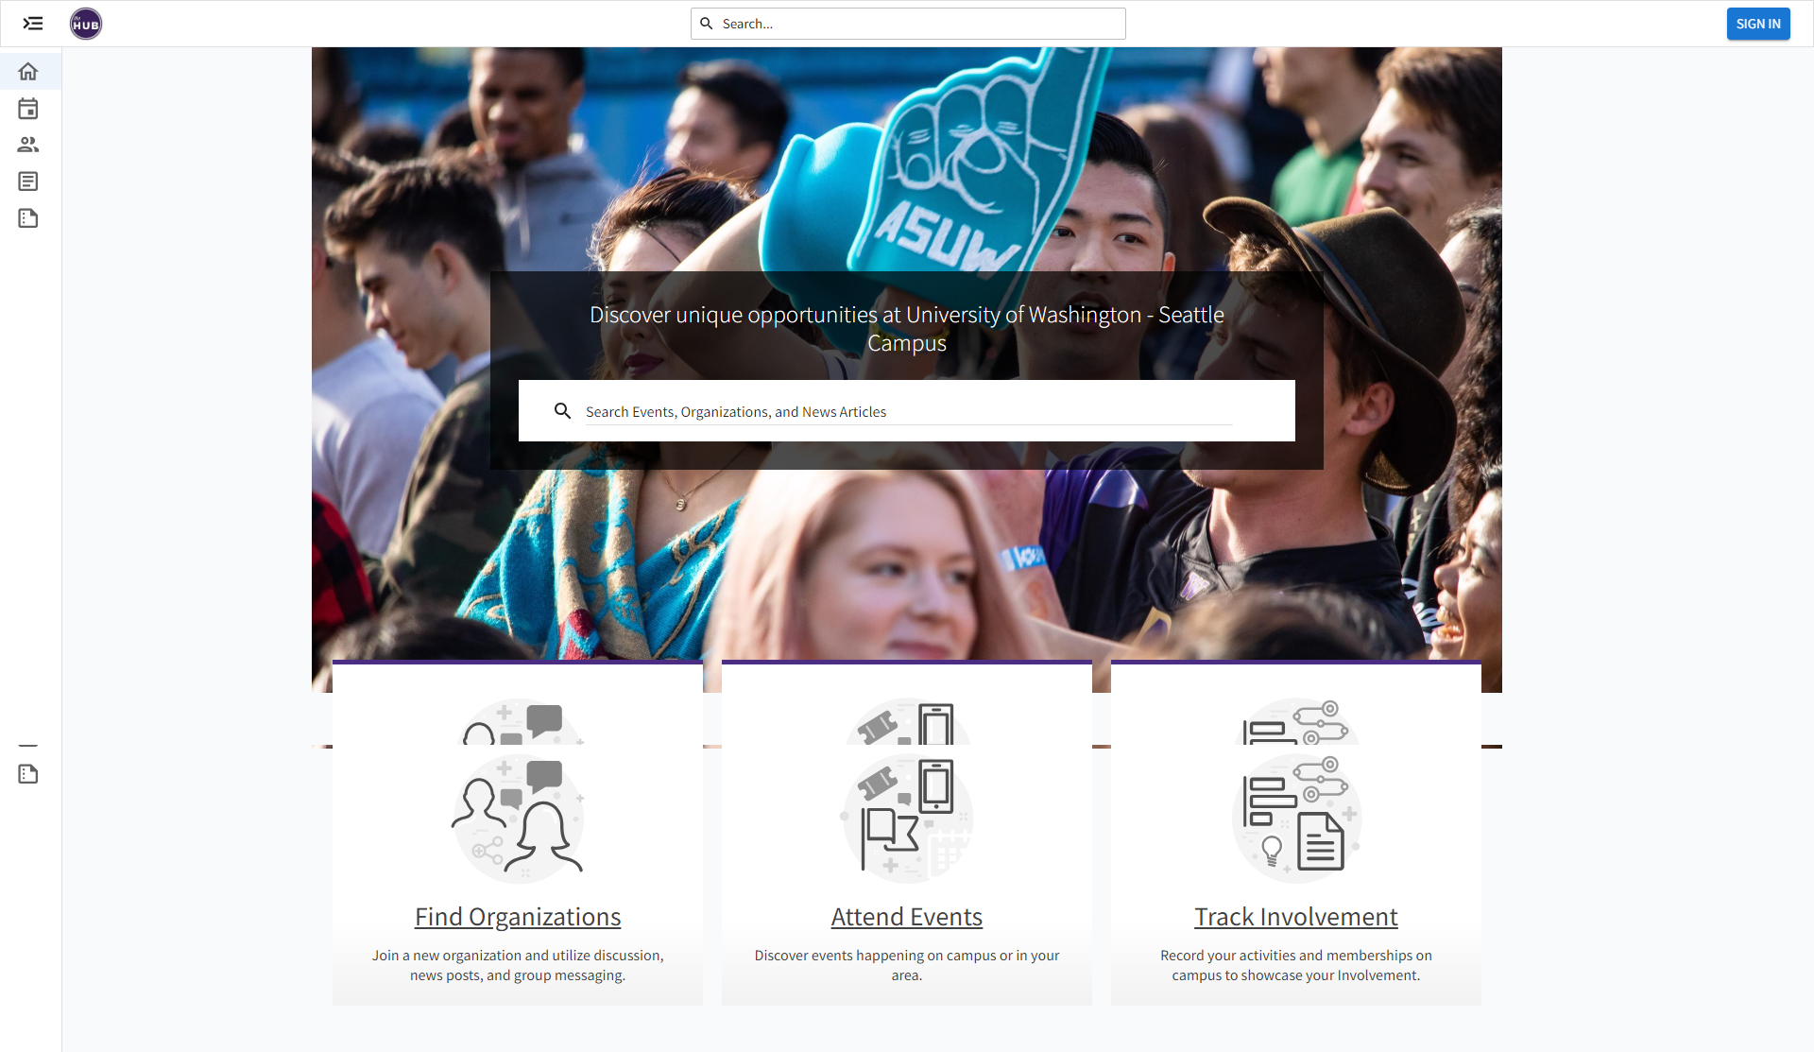

**Comparing Existing Solutions:**

|  | **Existing Solution 1** | **Existing Solution 2** | **Existing Solution 3** |
| --- | --- | --- | --- |
| **What does the existing solution do well?** | Google Events displays event information, including time, location, and date, with upcoming events highlighted for planning within the next month. Users can filter events for in-person or online attendance and seamlessly integrate events with their Google Calendar. Interactive mapping using Google Maps enhances the user experience by visually depicting event locations. | Handshake offers participant counts to gauge event popularity, specifies event formats (online or in-person), and provides essential event details like time, location, date, hosting companies, and event types (e.g., hiring event, career fair, guidance fair). Users can also access relevant job postings. | HuskyLink, exclusive to University of Washington (Seattle) students, serves as a hub for registered student organizations to announce their meetings, facilitating student participation. Its clean layout simplifies the discovery of student organizations, promoting engagement. Students can also track their involvement in campus activities, with integration for Google Calendar. Additionally, it offers links to navigate campus buildings and event filtering by themes and perks, like free food, to align with users' preferences and incentivize participation. |
| **Where does the existing solution fall short?** | Google Events primarily caters to public events, excluding UW student-specific events like club meetings, lectures/seminars, or special events not open to the public, such as the Makers Fair. Users looking for this information may need to explore alternative sources. | Handshake primarily focuses on career-related events and job opportunities, excluding club meetings, lectures/seminars, and university-specific special events. UW students seeking non-career-related event information may need to turn to other sources. | HuskyLink lacks embedded maps like Google Events, mainly targeting Seattle campus students, excluding Bothell and Tacoma. It also doesn't cover all UW events, pushing users to seek information elsewhere for lectures, special events, exhibits, and more across all campuses. |

**Similarity (Google Events, Handshake, and HuskyLink):**

Handshake, Google Events, and HuskyLink are similar in that they all serve as platforms for events and information sharing within the context of a university or campus community. Some common features and similarities include Event Information: They provide event details such as time, location, and date. Event Filtering: Users can filter events based on specific criteria, such as event type or format (in-person or online). Calendar Integration: They allow users to integrate event information into their calendars, making it easier to plan and keep track of events. University Focus: These platforms are tailored to serve the needs of a specific university or campus community (University of Washington in the case of HuskyLink).

# Stakeholder Groups

## Stakeholder 1

Student Body

Students directly interact with the existing solutions and with the new system. They are encouraged to join organizations to network and grow existing connections. The RSO directory is a necessity for students and offers an information system of clubs and opportunities. The Handshake application is effective in displaying information about career events, workshops, job opportunities (on and off campus), and even mental health awareness.

The current systems have inadequate advertising and lack up-to-date contact and event information. Student involvement growth would likely become stagnant if no changes were made. Students could also be ‘forced’ to approach other methods of finding information i.e. Instagram club accounts, club tabling, email newsletters, etc.

## Stakeholder 2

Student Organizations - Registered Student Organizations (RSOs), Residential Community Student Association (RCSA), Residential Programming Board (RPB), Housing & Food Services (HFS)

Student organizations use the RSO directory and Handshake application to input event information for student reference. The main motivation is to attract students because these systems provide opportunities to excel in their majors, departments, and social engagement. More student involvement in student organizations will help their growth and recognition. So, a directory combined with an event calendar is a productive redesign of the current systems.

The existing solutions are lacking in information from RSOs and events from RPB and HFS. RSOs should be required to input updated board members, meetings, date/time/location, and event information into the directory. RPB and HFS effectively promote their events through posters and social media, but would still benefit from a digital database. There is a poor representation of this on multiple instances on the website and

## Stakeholder 3

UW Faculty & Staff

Design, Development, Student Outreach

UW faculty developed this current system to provide students with a list of clubs while collaborating with Handshake that allows students to explore career opportunities (on and off campus). A new system could give more students access to school resources and support student organizations. Since community engagement is at the core of UW’s mission, improving outreach for student activities and organizations will effectively represent just that.

The current solutions are effective, but they could be so much more. Students are actively searching for current events and information, but instead, they often encounter outdated information. UW is a community and school. Featureless and complex systems will paint a poor picture of design and outreach at UW.

# User Research

Here are some helpful Blog Articles we recommend to read before you start the assignment:

User Research Plans:

* <https://uxplanet.org/user-research-can-help-to-avoid-big-design-mistakes-d017239f1986>
* <https://uxdesign.cc/unmissable-steps-in-user-research-44650e891869>
* <https://uxplanet.org/how-to-choose-a-user-research-method-985112051d84>

Surveys & Stakeholder Interviews:

* <https://www.interaction-design.org/literature/article/how-to-conduct-user-interviews>
* <http://boxesandarrows.com/a-stakeholder-interview-checklist/>
* [https://www.quickanddirtytips.com/education/grammar/how-to-write-good-survey-questions](https://www.quickanddirtytips.com/education/grammar/how-to-write-good-survey-questions?ref=startupmate)

We are giving you a couple weeks to do this research because it may take you a few days to discover who you should talk with, and arrange meetings. Get started on this early, and do not wait until the last minute. The people you need to talk with may be quite busy.

## 

## Surveys

### Survey Methodology and Purpose

* **What was the purpose of the survey?**   
  The purpose of the survey was to get more information from users that are affected by our problem statement and see what can be done to make it easier
* **Why was this research method appropriate?**

It was appropriate because it lets us connect with as many students who are affected by our problem statement as possible. By doing this, we can get as much user input as possible and use it to fix the issue we found.

* **What were the Distribution Methods used? Why?**

I distributed the survey on multiple platforms. I put it on my Instagram, I sent it through Whatsapp, and I asked some people verbally to fill it out.

* **What demographics were collected? Why?**

I collected statistical data on students and teachers, specifically students and teachers at UW. The questions related to students and teachers who go to UW and are familiar with the UW campus, events, websites, and social platforms. Students and teachers from other campuses will not be able to answer these questions. We only asked people related to UW because we are trying to fix a UW platform specifically, not another school’s platform or a general platform for students.

* **What were the Key Questions asked? Why?**

Some key questions that were asked were where do you hear about events, do you struggle with finding events, and what you would like to see on a new platform that we are working on. These are the main questions because we are trying to see what specifics the students struggle with and what are some key options students want in our solution. Using this information, we can understand the main issues and see what we should input into our solution website.

* **Link to the Survey Questions (ensure the link is working)**  
  <https://forms.gle/HhcwoKAGkLn93m4dA>
* **Link to the Survey Results (ensure the link is working)**

<https://docs.google.com/forms/d/1PlgLWvOJGXxmQlMmiSXmPT2JypvKZ0umnHe3fAApKp8/edit#responses>

### Survey Demographics and Key Insights

The survey garnered a total of 12 respondents. All of the respondents are students who either go to the University of Washington (UW) at the moment or went to UW in the past. Most students are from the UW Seattle campus, but some are from the UW Bothell campus. The age range of respondents falls between 18 to 24 years old.

**Key insights and learnings:**

1. The events that interest students the most are events that relate to their major/ minor, and fun events. Those are popular in general amongst the students, not just the students from the survey.
2. Most students find it difficult to hear about events that occur at UW, and some don’t. While some students don’t find it hard to hear about events, all students at the end of the day would like to have one well-working website that has all the event information on it.
3. Most students hear about events from Instagram, friends, and emails, instead of a UW website.
4. The most interacted applications for events are Handshake and Instagram accounts.

**Graphs from Google Survey:**

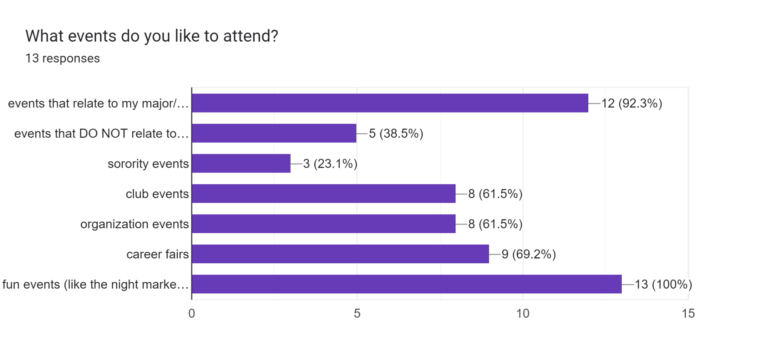

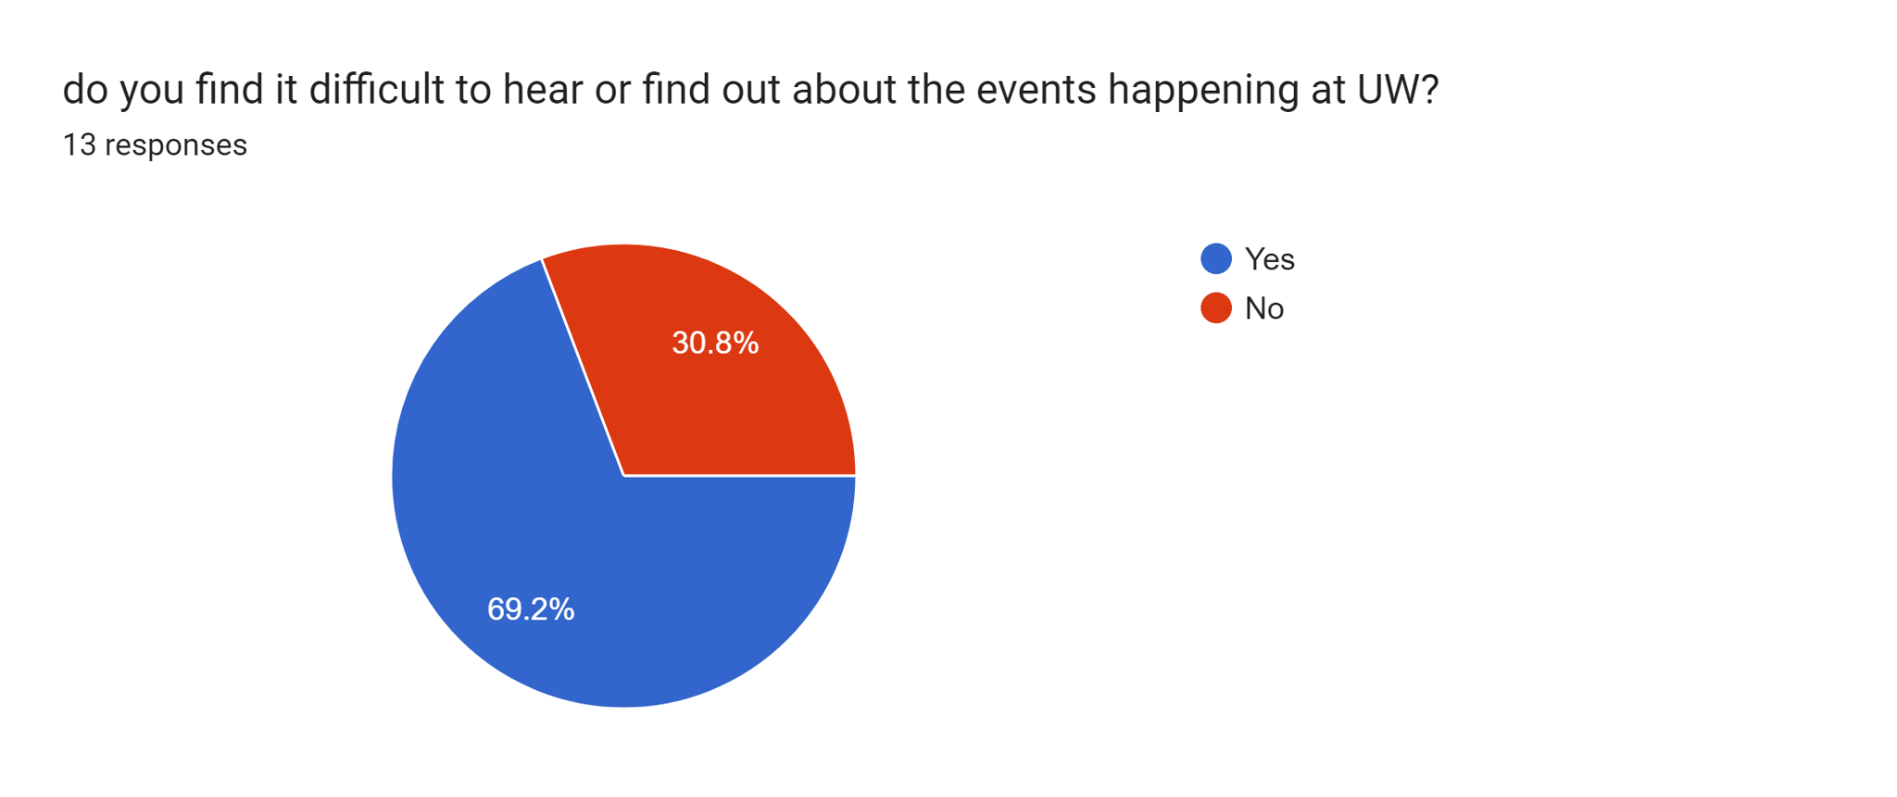

## Interviews

**We recommend using** [**https://userbitapp.com/**](https://userbitapp.com/) **to take your stakeholder interview notes easily.**

### Stakeholder Interview

I interviewed Mor, the leader of Mishelanu at the University of Washington. Mishelanu is the Israeli cultural club. The purpose of this interview was to research the perspective of a major stakeholder of the event information system, the student organizer. This interview showed me the current struggles of advertising events at the University of Washington and also some efficient methods of promotion. The research method of interviewing is appropriate for seeing a stakeholder’s perspective on the event information system. It is appropriate because it is more personal than any other research method. An interview is also very thorough and can collect a lot of information.

**Key Questions:**

* What student organization are you a leader in?
* How easy or difficult is it for you to advertise your events on a scale from 1-5? Why?
* Do you have any strategies you use to advertise your events to a specific audience?
* Can you share a positive experience you had with advertising your event at UW?
* Can you share a negative one?
* What suggestions do you have for improving the way event information is handled at UW?

These questions capture the strengths and weaknesses of the UW event information system from the perspective of the leader of a student organization. They provide insight into the experiences and preferences of those that actively promote and organize events.

**Key Insights:**

**Difficulty in event advertising:** The primary insight is that advertising events at the University of Washington is challenging. It can even be difficult to share information about an event with current members of an organization or club.

**Platform preferences:** The interviewee uses WhatsApp and Instagram to share information about events. This means that unless someone already follows the club or has asked to be added to the group chat, they cannot see event information. Also, even people who are in the groupchat or follow the account on instagram tend to miss messages and posts.

**Negative experiences and low turnout:** There were several mentions of negative experiences and low turnout for events. This is because event promotion is either not reaching the students or information is not being remembered by the students.

**Targeted advertising and personalization:** Sometimes the advertising might reach students, but not the correct audience of students. The interviewee suggested a user-based system where individuals can log in to a website, add their interests and even ethnicity, and then only see clubs that they’d be interested in or organizations that have interest in them. This would significantly improve the user experience and the event attendance.

### User Interview 1

I interviewed Timofei, a UW Seattle student that lives on campus. The purpose of this interview was to see the perspective of the user. We are researching what the user is experiencing right now with the events information system, the problems with the current information system, and what the user wants from the system. This research method was appropriate because it is a primary source of information. It gives direct insight into the student’s current experience with the event information system. Interviews in particular are important to us because it allows us to not only hear the statements made by the user, but also hear the tone and emotion behind each sentence.

**Key Questions:**

* What student organization, majors, or topics are you interested in?
* How easy or difficult is it for you to find information about events you are interested in on a scale from 1-5?
* Think about an event you attended. How did you find information about it?
* Do you have difficulty navigating to events?
* Can you share the most positive experience you have had with finding events you are interested in at UW?
* Can you share the most negative one?
* What suggestions do you have for improving the way event information is handled at UW?

These questions aim to understand the student’s personal experiences and preferences regarding event information at the University of Washington. They provide insight into how effective the current system is at catering events to individual interests.

**Key Insights:**

**Finding information:** The student stated that it is not too difficult to find information about events at the University of Washington, but he would prefer if it was less challenging at times. I believe it is hard for the student to know whether or not it is difficult, because he cannot speak on events that simply failed to be advertised to him.

**Platform preferences:** The student gets his event information through fliers and social media. I noticed that these responses on seeing advertisements were very different from the student organizer’s advertising. This means that there may be a disconnect between the advertising methods and the students’ attention. Also, the student says there should be a social media account for events at the university.

**Navigation to events:** The student said that for himself navigation is not an issue. He simply finds the location then walks there in a few minutes.

**Experiences:** The student said a positive experience was seeing a flier, remembering the details, then later that day attending the event. He stated that he has had no negative experiences, but also that he does not attempt to search for events.

**Suggestions for improvement:** The student suggests multiple social media accounts, each for a different genre of event. He believes this would enhance the discoverability of events for specific interests.

### User Interview 2

I interviewed a University of Washington (UW) student who goes to Bothell and Seattle campuses to gain insights into how they typically discover information about events at UW.The purpose of this interview was to delve into the user’s thought process and understand their preferred methods and challenges.

**Key questions:**

* What tools or resources do you typically use to find information about events on the University of Washington campus?
* How easy or challenging is it for you to locate event information on the University of Washington's official website or other platforms?
* Have you ever encountered any difficulties or frustrations while trying to find event locations on campus? If so, can you provide an example?
* Are there any specific campus locations or buildings that you find particularly challenging to navigate to for events? If so, which ones and why?
* What suggestions do you have for improving the way event information and navigation are handled at the University of Washington?
* Recall a positive experience you've had with navigating for events on campus. What made it a positive experience?

I believe these questions helped me understand the user because since they are cross-campus student, they shared with me some personal experiences when looking for events (online and physically). For event locations, they were challenging to navigate, particularly when building names and room numbers were insufficient. They often resorted to physically seeking directions from others on campus.

**Key insights:**

**Finding Information:** The user’s primary sources for event information at the University of Washington include flyers around campus, social media, event information (career fairs/hackathons), email, and the UW website. However, navigating through the UW website, was confusing and time-consuming, leading to challenges in finding event information efficiently.

**Platform Preferences:** The user is not able to find the information they are seeking for easily/efficiently. They would often need to navigate through different campus websites (Seattle, Bothell, and/or Tacoma).

**Navigation to events:** The user is a cross-campus student and finds it quite difficult to navigate for event locations, due to both campuses being different and sometimes, the building name and number are insufficient for clear directions. They would need to ask someone for directions, as it would not be clearly stated on the event information page.

**Experiences:** The user expressed a strong preference for a more intuitive and organized format on the main website of UW. To reduce the need to seek alternative sources which can be frustrating and confusing.

**Suggestions for improvement:** The user had a positive experience when they would see flyers around campus because the graphics were eye-catching and whenever there was a holiday-related event, it would be on the UW main page. UW would categorize this by displaying the day, time description, and image that represents the event. The user values not only the availability of pertinent event information but also the visual appeal and organization of event details.

# User Personas

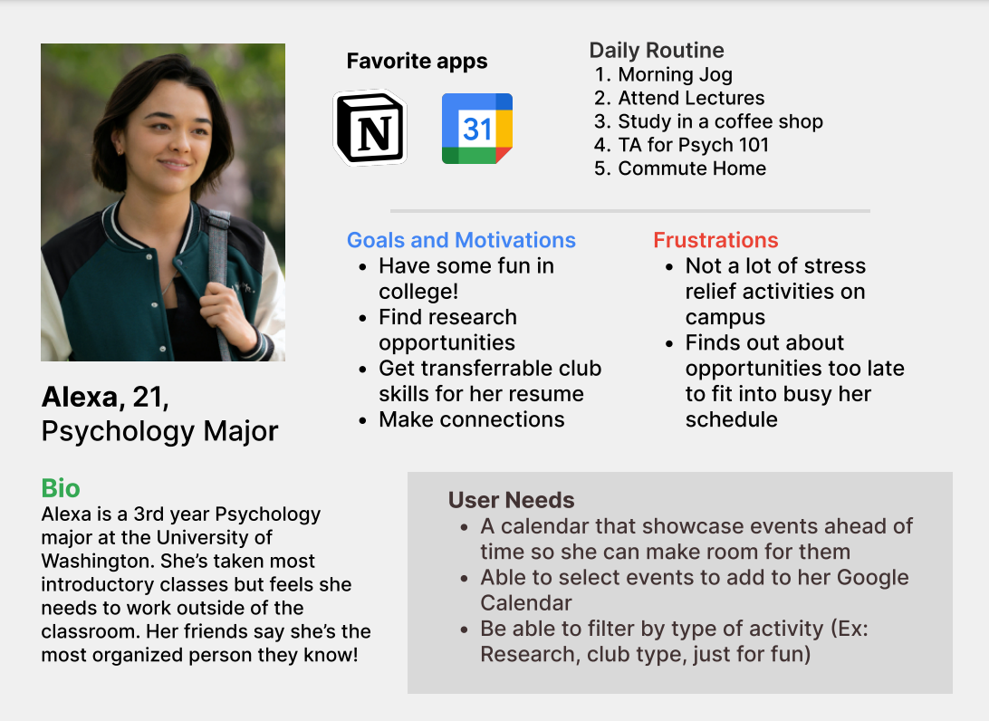

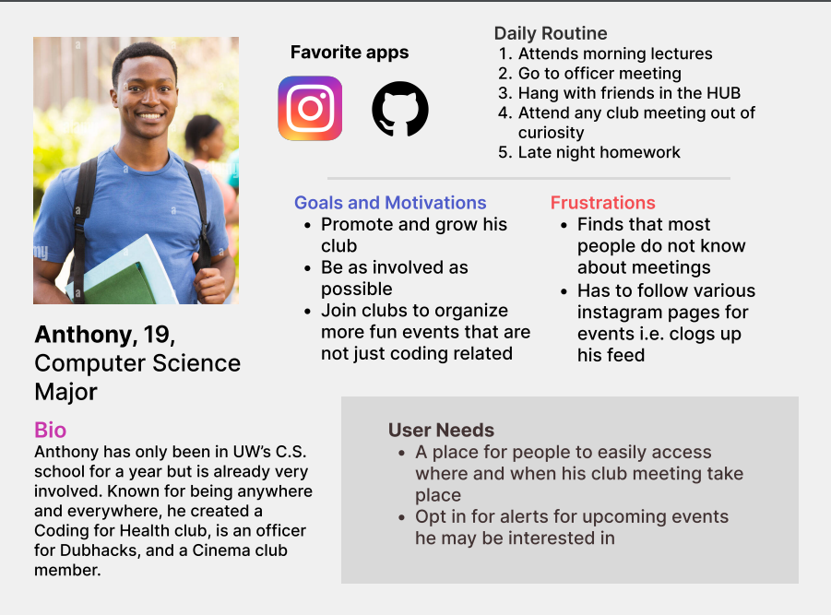

# Conclusion

Through research on existing solutions, and stakeholders, and conducting interviews/surveys. University of Washington (UW) students have specific preferences and challenges when it comes to navigating and staying informed about events on campus. In conclusion, there is a clear consensus among students and stakeholders that a more user-friendly, comprehensive, and up-to-date event information system is needed at UW. This system should cater to a wide range of student interests and organizations while streamlining event discovery and participation. Improvements in outreach and design will not only benefit students but also better represent the university's commitment to community engagement and support for student activities.

To address these concerns and meet the needs of the UW community, our next step is to create a centralized website that includes necessary features and aggregates event information from all campuses within the University of Washington system. Such a website will prioritize ease of access for a seamless user experience in searching for events.

# 

# Bibliography

Please include all your references. You can use [bibme.org](http://www.bibme.org/), [citethisforme.com](http://www.citethisforme.com/) or similar to help you with this.

*Events | HandShake*. Handshake. (n.d.). https://uw.joinhandshake.com/stu/events?collection=ALL&eventFormat=HYBRID&sort=RELEVANCE&date=ALL

*Explore - registered student organizations UW (RSOs)*. Explore - Registered Student Organizations UW (RSOs). (n.d.). https://huskylink.washington.edu/

Google. (n.d.). *UW Events*. Google. https://rb.gy/nvbc5

Interaction Design Foundation. (2023, November 4). *How to conduct user interviews*. The Interaction Design Foundation. https://www.interaction-design.org/literature/article/how-to-conduct-user-interviews

Roscoe, J., & Koch, M. (2022, September 20). *Opinion: Handshake is not letting NYU students shake any hands*. Washington Square News. https://nyunews.com/opinion/2022/09/20/nyu-students-should-abandon-handshake/

*User persona template and examples*. Xtensio. (2023, October 27). https://xtensio.com/user-persona-template/

# 

# Appendix

## Interview Notes

## User Interview 2 Notes:

* Cross-campus student (Bothell and Seattle)
* Challenging for cross-campus students to find building names and number
  + They are different from each campus
* Appealing graphic design flyers is a plus
* Social media is often used to announce different events at UW
  + Each club typically has its social media
* The user appreciates knowing if the event offers incentives (such as free food or something free merch)
* Messy organization of event information is time-consuming and confusing
* Find event information online
* Gain event knowledge through flyers, word-by-mouth, social media, email, and UW's main website

## Survey Results

* <https://docs.google.com/forms/d/1PlgLWvOJGXxmQlMmiSXmPT2JypvKZ0umnHe3fAApKp8/edit#responses>